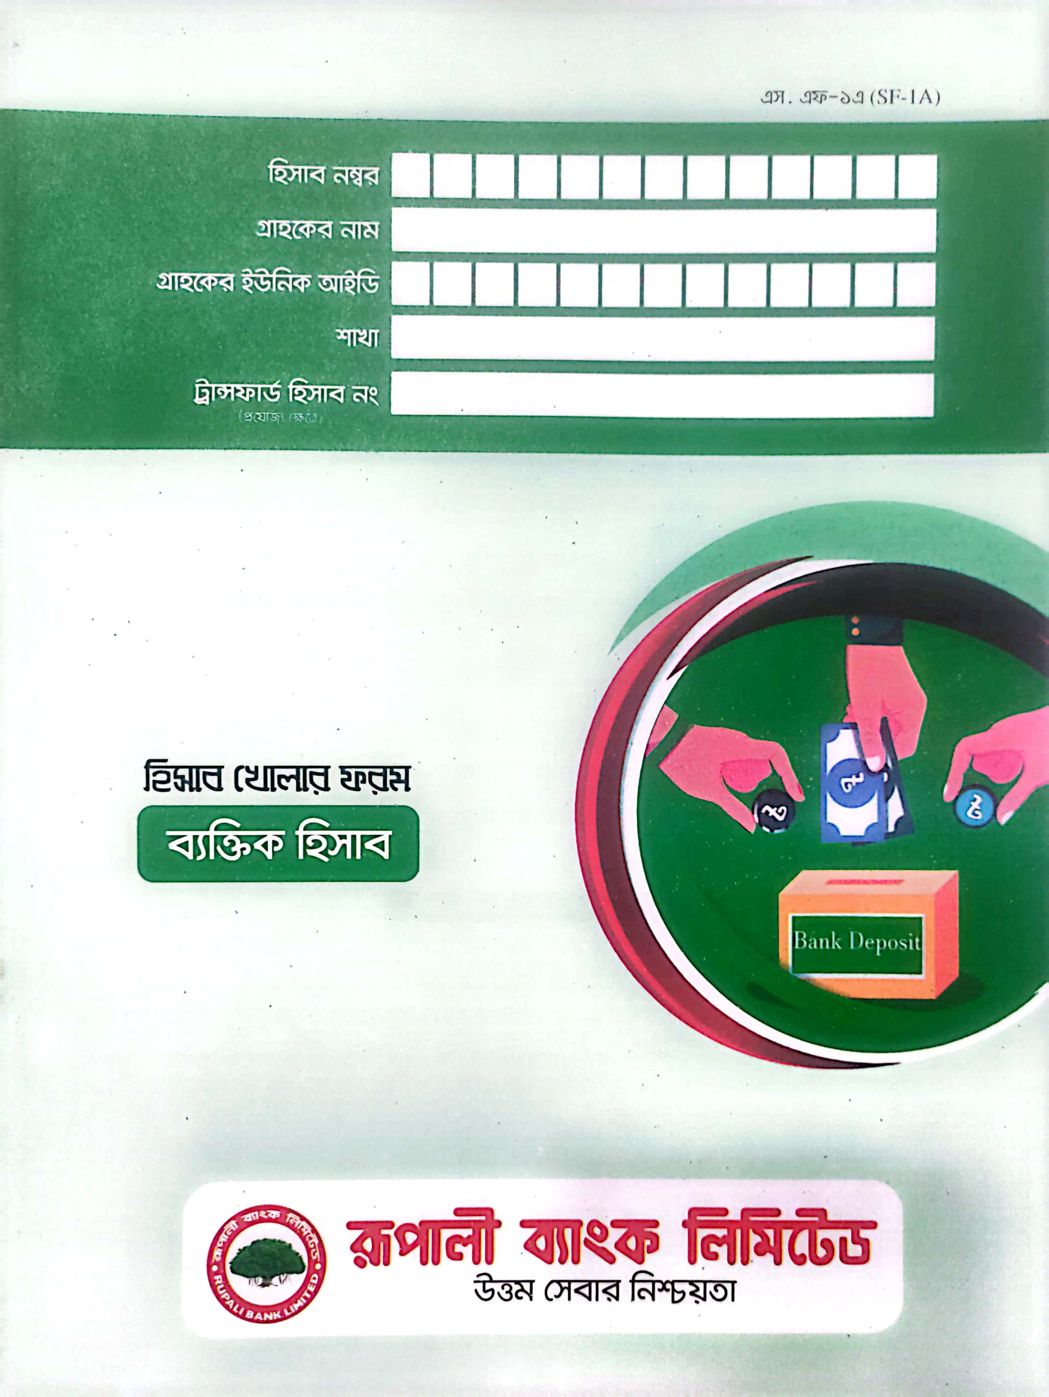

__b_name__

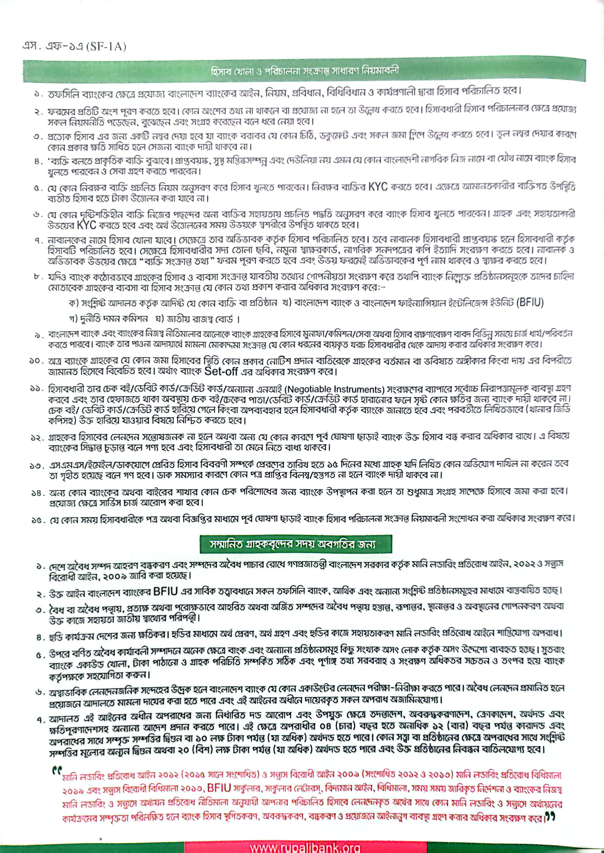

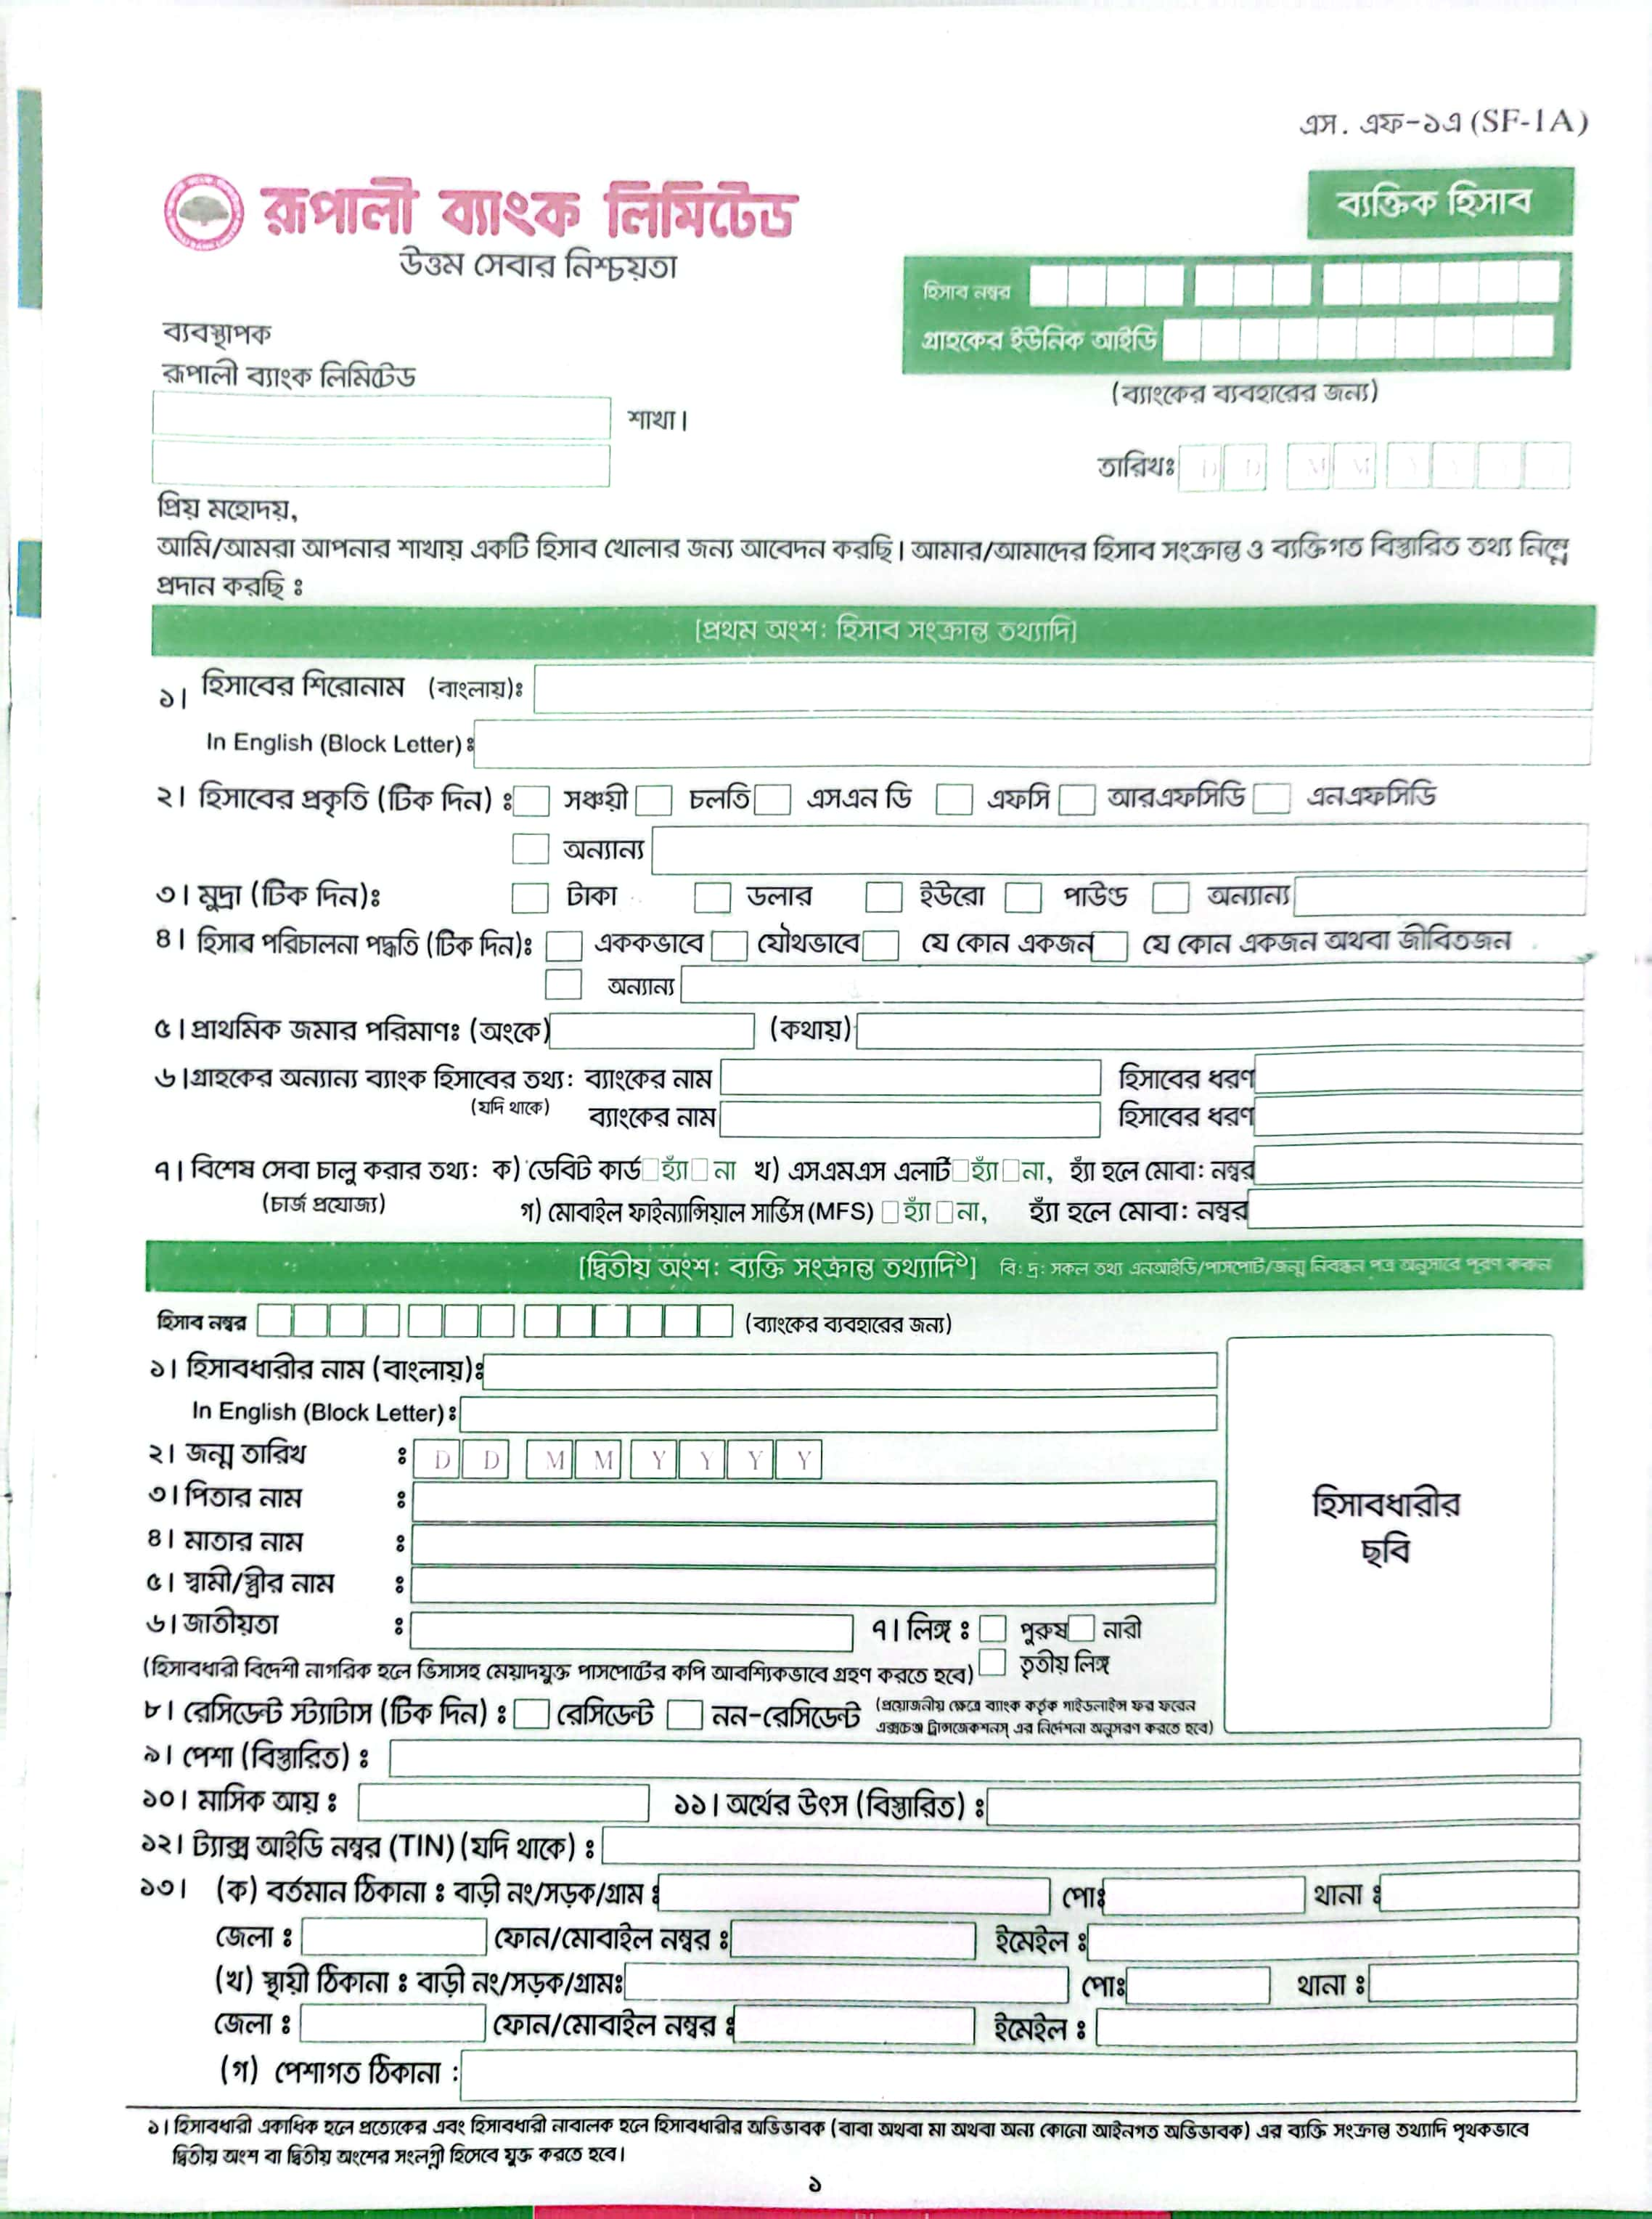

__date__

__b_name__

__e_name__

__b_name__

__e_name__

__dob__

__f_name__

__m_name__

__s_name__